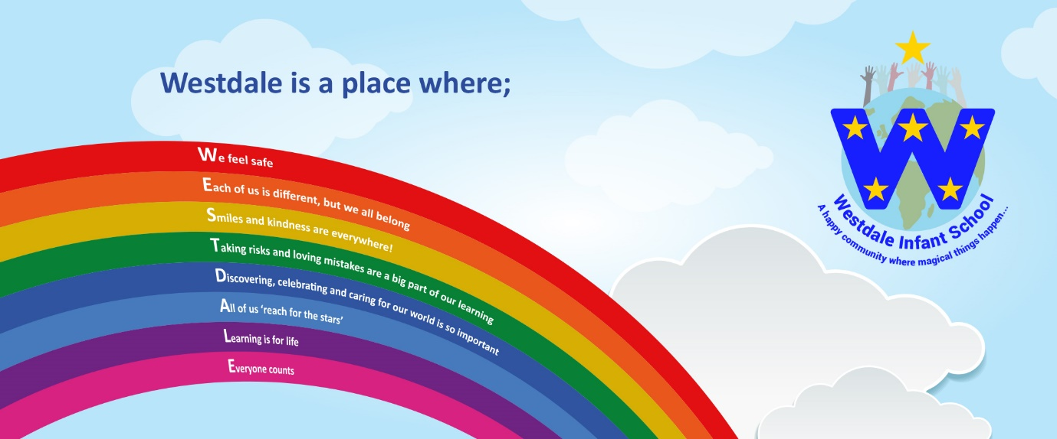

Job Title: Little Stars Nursery Teacher (Maternity Leave)
Salary: Main Scale
Hours: Wednesday to Friday to December 2027
Location: Westdale Infant School, Mapperley, Nottingham NG3 6ET
Telephone: 0115 9531606 Head Teacher: Rebecca Lewis
Roll: 180 + 26 place Nursery
Required for: January 2027
Closing Date: Monday 2nd November 2026 at 9am
Interviews: Week Commencing 9th November 2026
We are looking for a committed, enthusiastic and innovative teaching colleague to join our dedicated team working in our Little Stars Nursery Class.
Westdale is a busy and welcoming school with a strong focus on early years. We are highly respected in our community for our inclusive and nurturing provision alongside our focus on high expectations for all children.
The successful candidates will:
- Have experience of working across the infant school age range and be passionate about teaching this age group
- Have high expectations of pupil achievement and behaviour
- Have the knowledge and commitment to ensuring strong foundations in learning to enable all of our children to succeed
- Be ready to embrace new initiatives and school priorities
- Have excellent interpersonal skills and work well in a small, supportive team
- Be reflective, kind, creative thinking, energetic and hardworking
- Have an all-important sense of humour
- Be willing to lead or support in a subject area
- Delight at being with our children putting their wellbeing and progress at the centre of all they do
- Be able to inspire a love of learning, excitement, and curiosity
We can offer you:
- A truly supportive and welcoming team who are passionate, dedicated and motivated and who put children at the heart of every decision
- A leadership that will trust and value your expertise, professionalism and voice
- A school that believes in nurturing and investing in the whole child
- A commitment to supporting and promoting your expertise and continuing professional development
- Truly wonderful children! The children have said that they work hard and are kind!
- A commitment to supporting your wellbeing
Interested? We would love to hear from you! Applications from ECT’s are welcomed. Application packs are available via email from office@westdale-inf.notts.sch.uk and are on our school website www.westdaleinfants.com
Visits to the school are warmly welcomed and actively encouraged - we would love to show you why Westdale Infants is such a magical place to be and why you need to join our team. Please phone for an appointment 0115 9531606
You can also find further information about us on our school website www.westdaleinfants.com
Our school is committed to safeguarding and promoting the welfare of children and young people, therefore all positions are offered subject to an enhanced DBS disclosure and references confirming your suitability to work with children.

