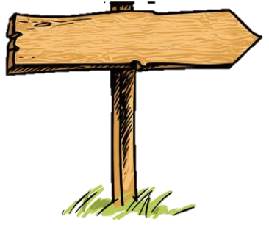
Tales and Rhymes, Story Time! Topic Trail –Little Stars Spring 1
Here is some of the learning that we will be focusing on this half term for you to discuss and research at home

Topic Trail
Topic Opener:
Making an animal print headband using spots, stripes or scales

Our key values this half term:
Kind star
Celebrating difference
Key Questions
What do I like to do?
How am I feeling?

Vital Vocabulary
above beneath around between
different same confused happy sad angry relaxed loved

Communication and Language
Can retell a story in my own words.
Can have a 2 way conversation with an adult or child.
Can express my needs.
Can learn a new song.
Can talk about what interests me and what I like.
Can remember and use vocabulary from my topic/books.
Personal, Social and Emotional Development
Can identify the different emotions in stories and our feelings house.
Know that I should stop and tell a grown up if anything comes on my screen.
Can hang my coat up.
Can put my coat on – hood on, arms in.
Know that there are similarities and differences between me and my friends.
Recognise that some actions and choices can hurt others.
Physical Development:
Know how to balance on one foot and putting my arms out helps me balance.
Know how to run, negotiating space.
Beginning to follow the rules when playing a game.
Can copy actions and move to music.
Use my feet on the pedals to make the tricycles move.
Can use tweezers.
Starting to do the first part of the zip on my coat.
Understanding the World:
Starting to make sense of my life and family.
Interested in photographs of myself and my family.
Interested in other children in nursery.
Enjoy joining in with family customs, eg. Chinese New Year.
Know there are different countries in the world and talk about their differences

Maths:
Know about 1 and 2, once/first, twice
Count using my fingers body to 1 or 2.
Can respond to a question that isn’t 1 or 2.
Can join in with nursery rhymes including 1 and 2.
Can start counting at different numbers up to 5.
Can understand and use between, above, beneath, around
Know what is happening in a day eg, first, then, next.
Can sequence stories and draw a story map.
Literacy:
Can choose library book and say why I have chosen it.
Know that labels, menus and recipes have words on them.
Know that print goes from right to left.
Can talk about the main events in a story and the main characters.
Can predict what might happen next in a story.
Can recognise my name without a photograph.
Know to spot the first sound of a word not the letter.
Learn Supersonic Phonic Friends actions for several sounds.
Know how to make marks (from last term and circles, loops)
Link marks to letters in my name.
Use a tripod grip when mark making.
Expressive Arts and Design:
Know the name of a famous artist and have looked at his work.
Know how to use different tools and colours when painting.
Have my own ideas about what materials I want to use.
Know different emotions and which colour matches each emotion.
Know the movements to make more complex marks like a face.
Use puppets and small world to retell stories.
Can use different percussion instruments with control.
Can follow the lead of a singer when singing songs eg. pitch.

Key and Supportive Texts








